Here’s a copy of the argument map:
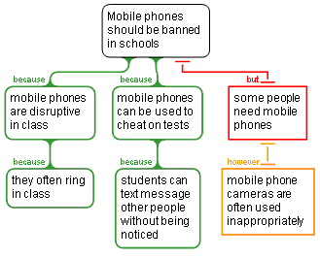
Take this list of the claims and cut and paste each into the most suitable place in the mini-essay below:

- Mobile phones should be banned in schools
- mobile phones are disruptive in class
- mobile phones often ring in class
- mobile phones can be used to cheat on tests
- students can text message other people without being noticed
- some people need mobile phones
- mobile phone cameras are often used inappropriately
Cut and past a claim into every marked place (…) in the plan below. You will need to copy the position so it can be pasted in more than one place in the essay.

Introduction | … There are two main reasons supporting this position, and the main objection to it can be rebutted.
Body | The first reason is that… since…  The second reason to think that… is that…This is because…  On the other hand, a consideration against the idea that… is that…This objection is not convincing, however, because…
Conclusion | Based on this reasoning it is clear that…

